**MIT xPRO Data Engineering Certificate**

**Dask, Feather, Parquet**

Feather and Parquet are formats that can be used to handle very large volumes of data. DASK is a Python library used to handle big data, which takes advantage of how modern computers are set up with multiple cores to run processes in parallel.

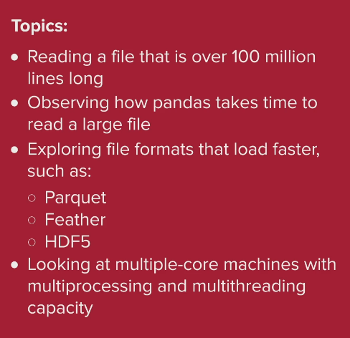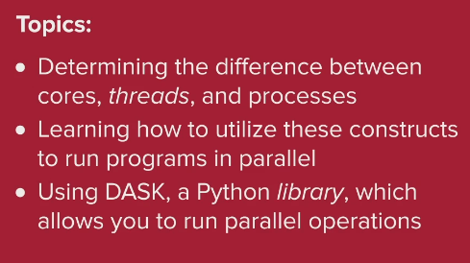

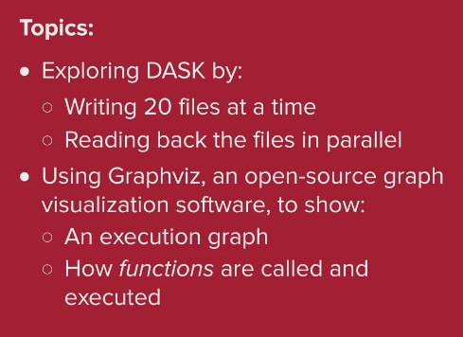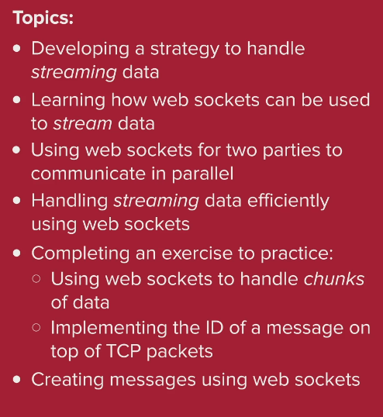

How to read a large CSV file in Python to a pandas dataframe, and output the file using the Parquet and Feather formats:

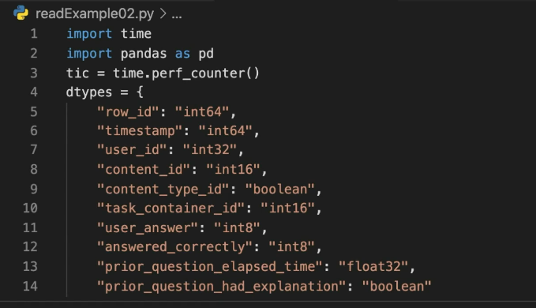

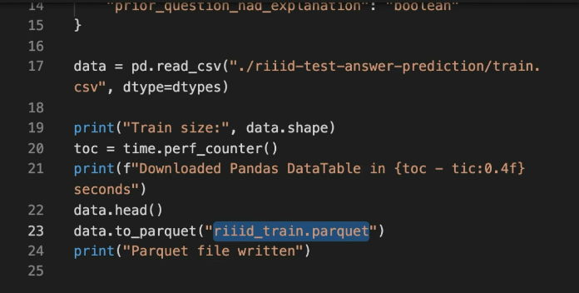

DASK is a parallel computing Python library. You can use the DASK library to create, read, write, and analyse multiple files in parallel, and you can simulate parallel processing across distributed machines using DASK.

The architecture of computers with multiple cores allows programs to run in multiple threads. Threads allow sections of a program to be executed at the same time, in parallel, with different priorities.

In this example, the increments functions are run in parallel, whilst add must be run sequentially:

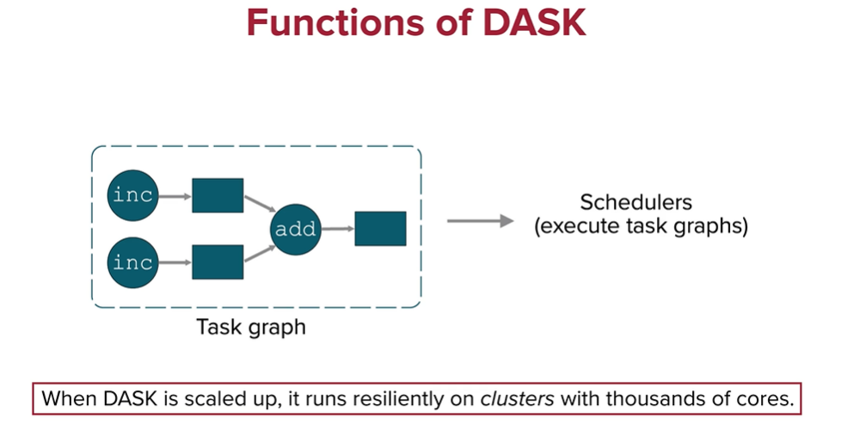

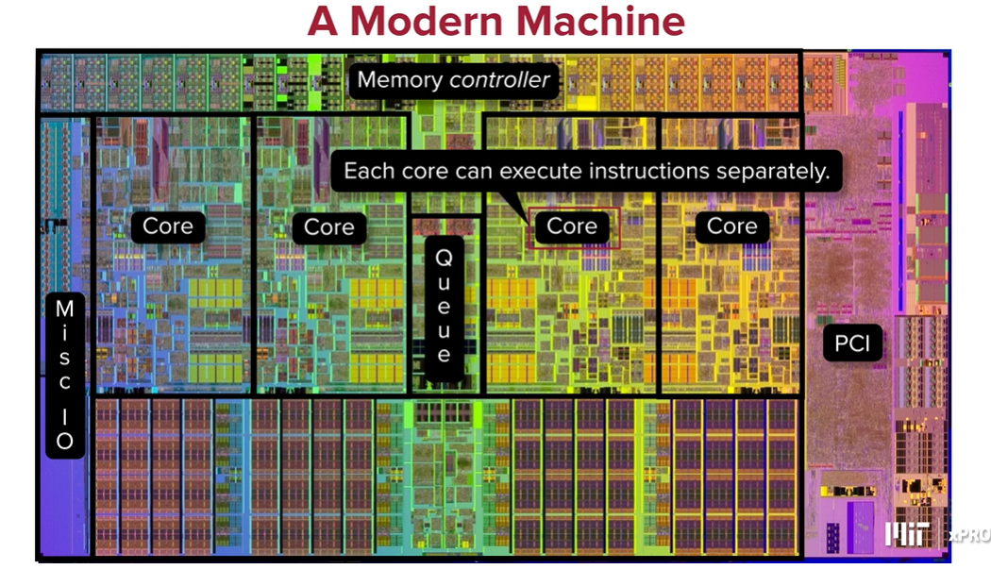

A clock cycle (or clock tick) is the smallest unit of time in a CPU, determined by the CPU clock's frequency. For example, a 3 GHz CPU has a clock cycle of 1/3,000,000,000 of a second. When referring to cache, clock ticks usually indicate the number of cycles the CPU needs to access data from the cache. If data is in the cache (a cache hit), accessing it will take fewer clock cycles compared to accessing data from the main memory (a cache miss).

The cores have access to different levels of cache. Modern CPUs have multiple levels of cache:

* L1 Cache: Fastest and closest to the CPU cores, usually takes 1-3 clock cycles to access.
* L2 Cache: Larger but slower than L1, typically takes 10-20 clock cycles.
* L3 Cache: Even larger and slower, but shared across CPU cores, usually takes around 30-50 clock cycles.

Cache memory is located on the CPU chip (L1 and L2) or on a separate chip close to the CPU (L3). RAM is the main memory and is located on the motherboard separate to the CPU. RAM is much larger than cache, but cache is much faster to access and more expensive.

When a CPU needs data, it first checks the cache. If the data is not there (a cache miss), it then checks the RAM. If the data is not in RAM either, it will retrieve it from the storage device (e.g., SSD or HDD), which is much slower. By keeping frequently accessed data in the cache, the system can operate much more efficiently.

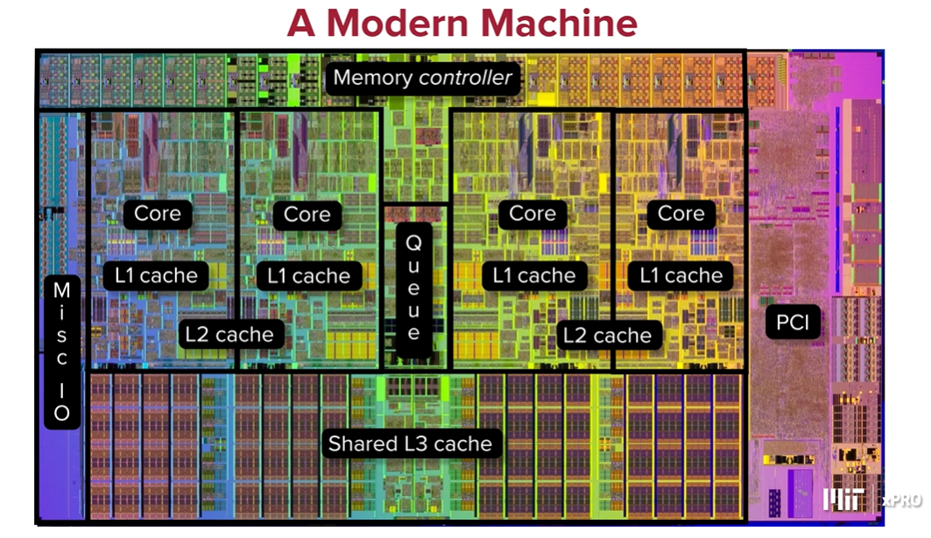

Threads:

* A core operates on a set of instructions from threads.
* A core can swap threads in and out over time.

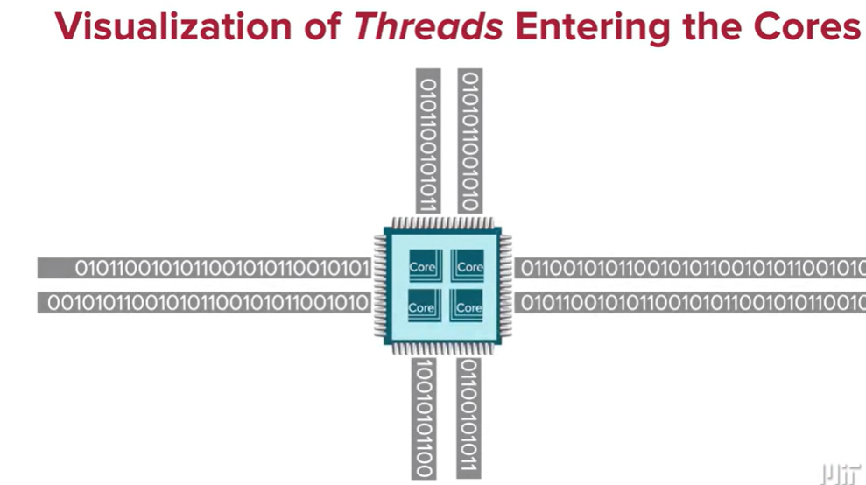

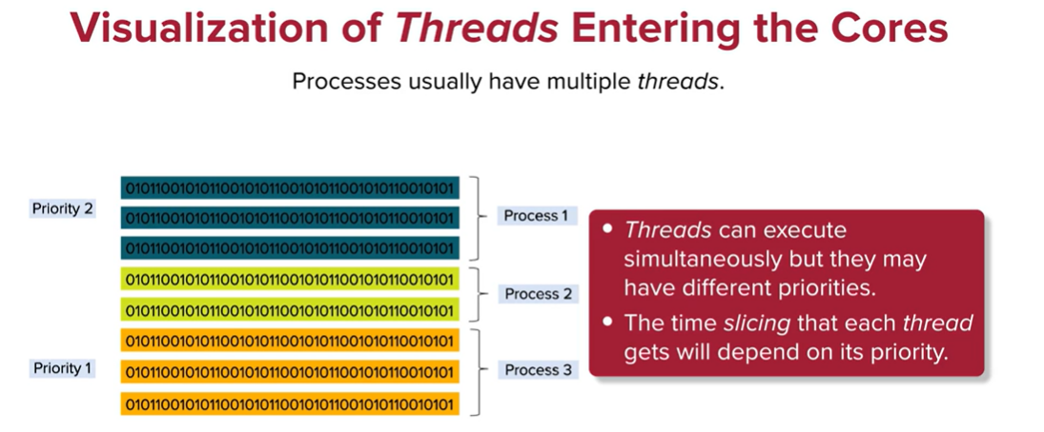

Note: Time slicing is a technique used in multitasking operating systems to ensure that multiple threads (or processes) get a fair share of the CPU's time. The goal of time slicing is to allow each thread to run for a small, fixed amount of time (a "time slice" or "quantum") before the CPU switches to another thread. This helps achieve concurrent execution of threads, even if there are more threads than CPU cores available.

You scatter tasks across multiple threads and then gather the results, with the possibility that the threads complete their tasks and return results at different times or in a different order than they were dispatched. This concept is common in parallel and distributed computing to improve performance and efficiency.

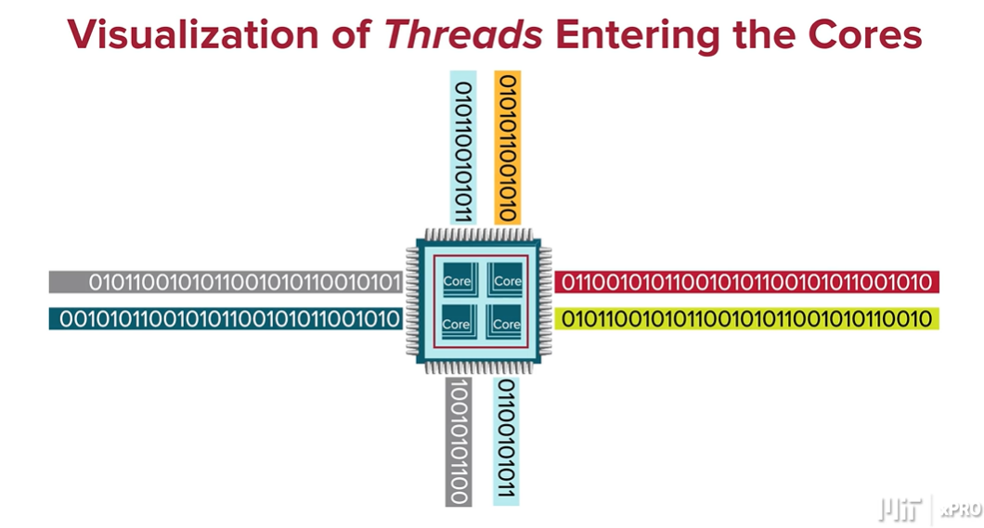

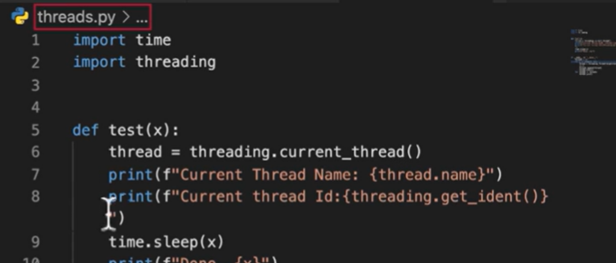

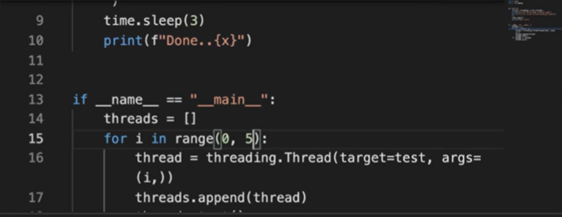

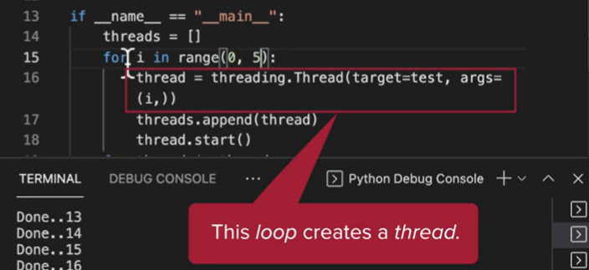

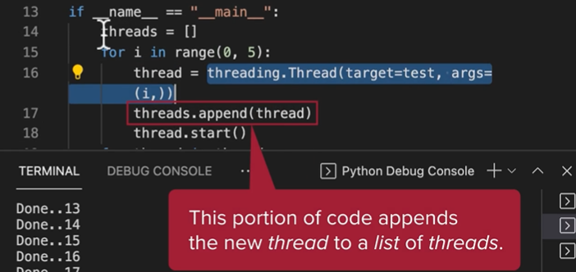

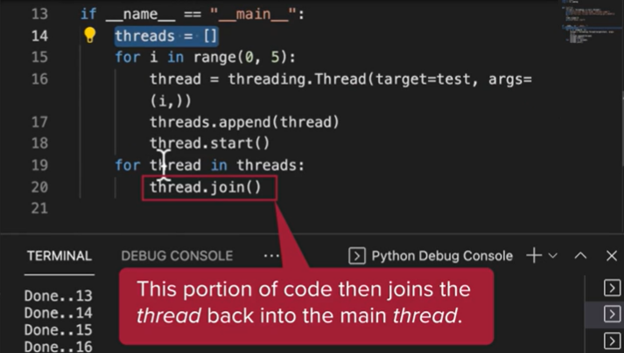

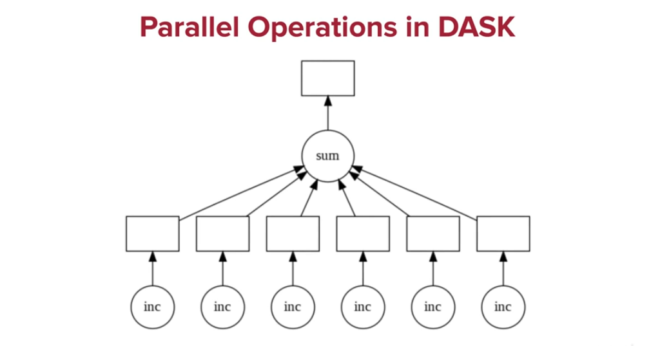

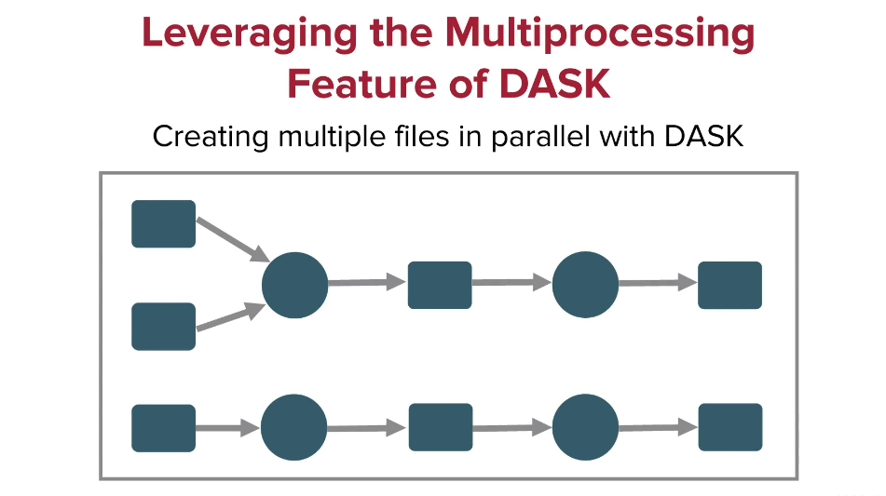

You can use DASK to create 30 files in parallel. This program creates synthetic time series data and places them each in a csv file. Each file has thousands of lines with one line for each second of a day and each day in a file. The column headers are: timestamp,name,id,x,y:

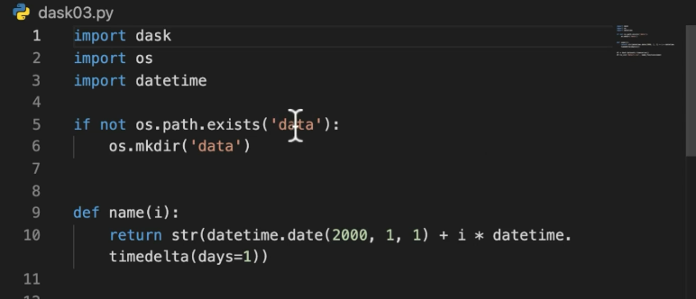

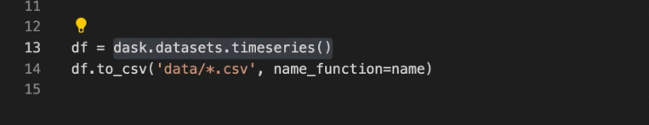

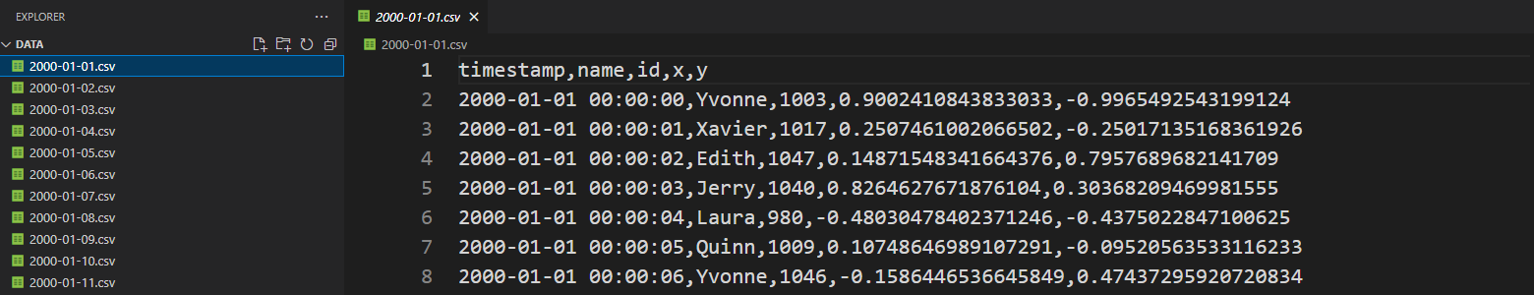

This program reads the files in parallel. It creates a single dask dataframe out of several pandas dataframes (ie those stored in the 1-30 csv files:

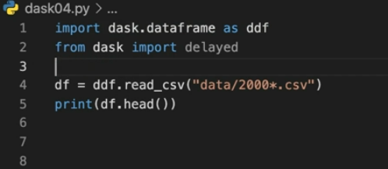

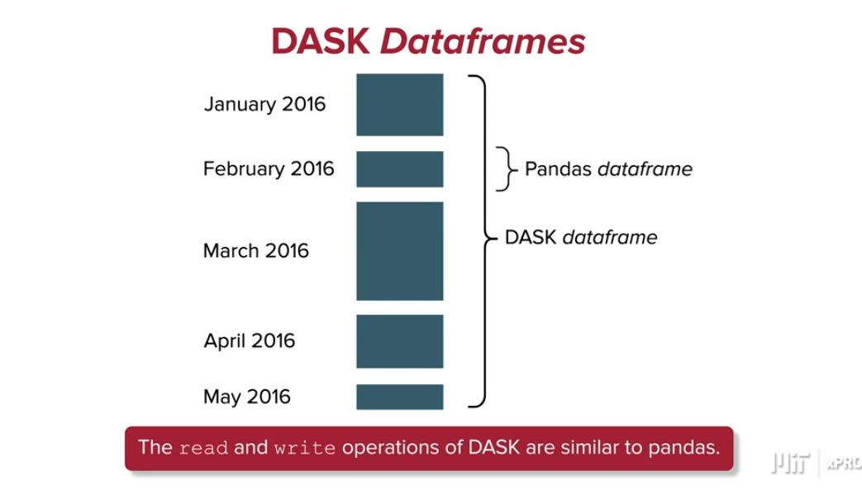

This program calculates the mean of the x column in all of the lines of the dask dataframe. The compute() function spreads the computation workload in a parallel fashion:

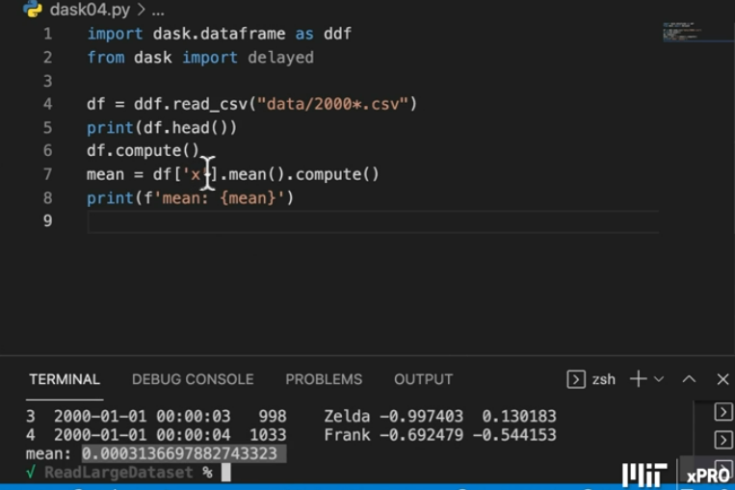

This program also calculates the number of columns and rows in the dask dataframe:

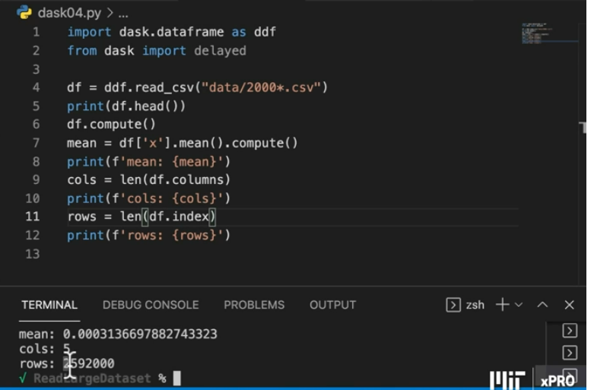

DASK allows you to distribute computations and other tasks across different machines. This simulates the process using different windows. First launch the dask-scheduler. Then create 2 workers that connect to the same scheduler:

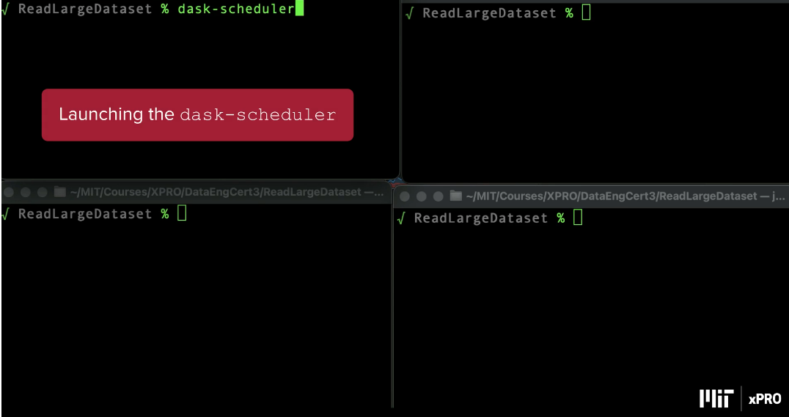

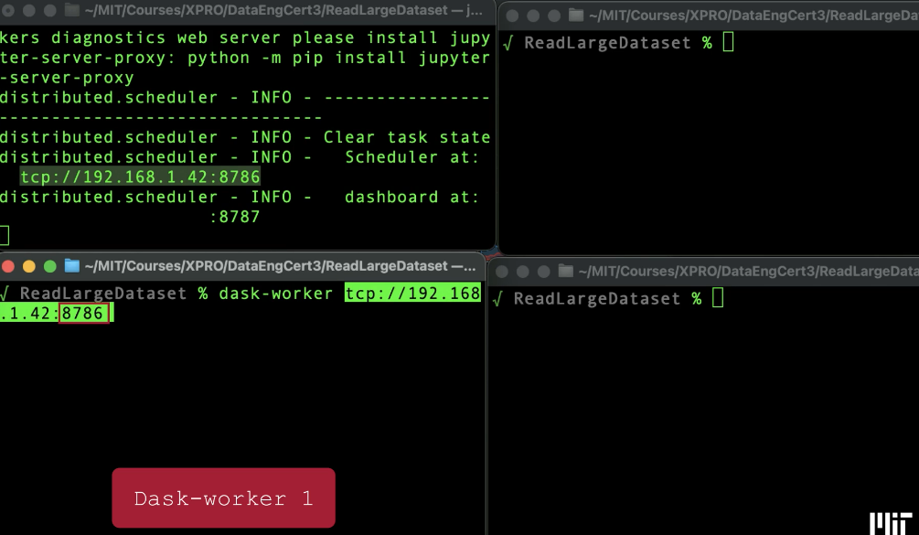

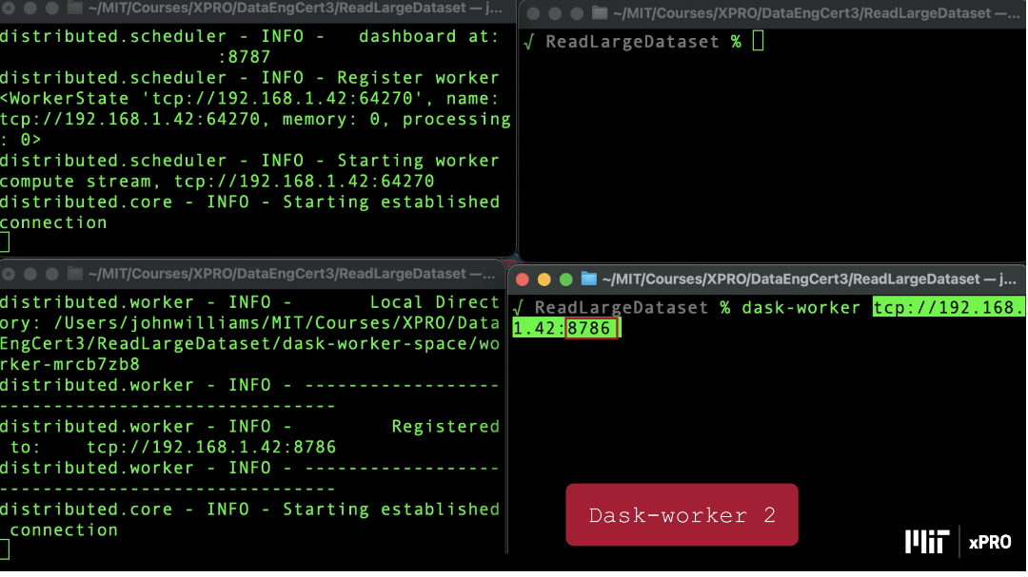

Then create a client using python:

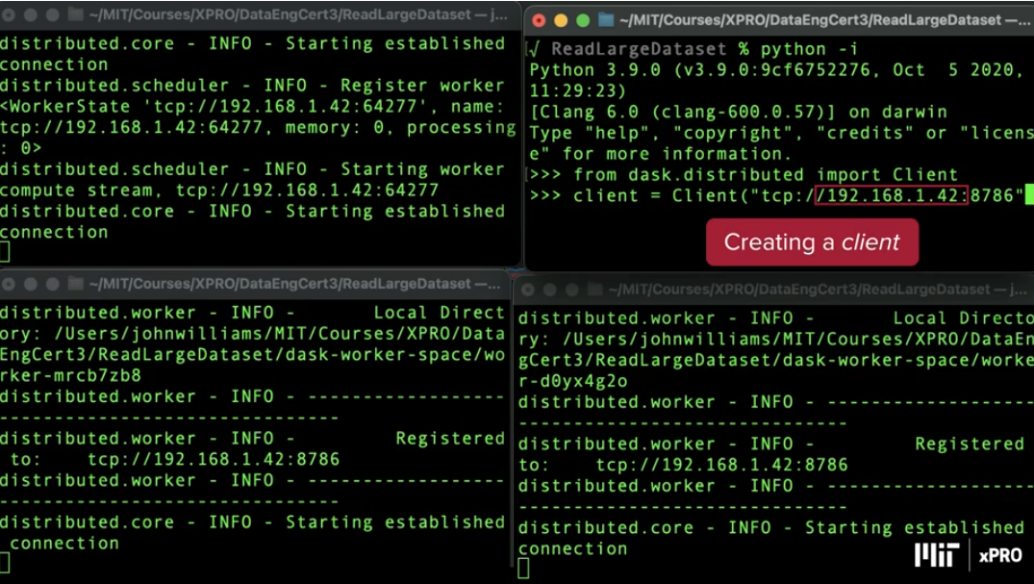

And then use python to write a program:

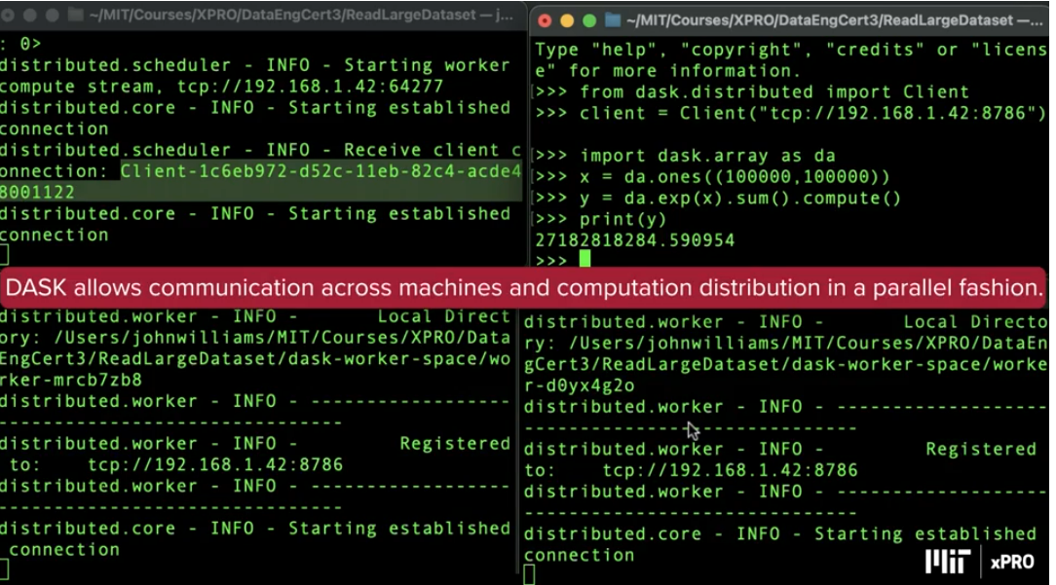

Crtl + C to take down the scheduler, which logs out each of the windows.